
Anekant Education Society's
Tuljaram Chaturchand College of Arts, Science and Commerce
Baramati
Department of BBA(CA)
A Project report on
“Quizzes for Students”
Submitted in partial fulfillment of the requirements
For the award of degree of
BBA(CA)
Submitted by

1)Mr. Prashant Bukan
Seat No: -2659
2)Mrs. Mansi Shahane
Seat No: -2703

Under the guidance of
Prof. A. V. Bhosale


Anekant Education Society's
Tuljaram Chaturchand College of Arts, Science and Commerce
Baramati
Department of BBA(CA)
A Project report on

CERTIFICATE
Seat No: - 2703 Date: -15/03/2023
Seat No: - 2659

This is to certify that the project entitled “Quizzes for student” submitted by Mrs. Mansi Shahane and Mr. Prashant Bukan in partial fulfillment of the requirements for the award of degree of SY B.B.A(C.A) to Savitribai Phule University of Pune, has been carried out by them under my guidance satisfactorily during the academic year 2022-2023.

Project Guide H.O.D

Internal Examiner External Examiner

ACKNOWLEDGEMENT

We are thankful to Dr. C.V. Murumkar Principal of
Tuljaram Chaturchand of Arts, Science and Commerce College, Baramati
for making available all the required resources and co-operation in our project work.
We are thankful to Prof. Patil S.P. Head of BBA(CA). Department. Tuljaram Chaturchand College, Baramati for making available all the required resources and co-operation in our project work.
It gives us great pleasure to express gratitude to Prof.. A. V. Bhosale for her valuable guidance and suggestion while preparing this project.
I wish to express my sincere thanks to B.B.A(C.A) Department and all teaching and non-teaching staff. For their extraordinary help throughout period of my project. We are especially thankful to those who helped us directly-indirectly in completion of this work successfully.

Date: -15/03/2023 Mansi Shahane seat no- 2703

Place-Baramati Prashant Bukan seat no-2659

INDEX
Sr.No | Contents | PageNo.
1 | Introduction to System | 5
1.2 | Scope of the System | 6
1.3 | Existing System | 7
1.4 | Need for new system | 8
1.5 | Proposed System | 9
1.6 | Operating Environment | 10
1.6.1 | Hardware and Software Requirement | 10
2 | Fact Finding Techniques | 11
2.1 | Feasibility Study | 11
3 | Module Description | 12
4 | System Design | 13
4.1 | ER Diagram | 13
4.2 | Context Level Diagram | 13
4.3 | Data Flow Diagram | 14
4.4 | Class Diagram | 15
4.5 | Use Case Diagram | 16
4.6 | Sequence Diagram | 16
4.7 | Deployment Diagram | 17
5 | Data Dictionary | 18
6 | Inputs Output Screens | 19
7 | Conclusion | 22
7.1 | Future Enhancement | 22
8 | Bibliography | 23
9 | Annexure(Sample Code) | 24

1. INTRODUCTION TO SYSTEM

- This Students project aims to make a website for first-year students of our university This is an e- learning website where first-year students of our university can practice and come to know that how much knowledge they actually got. Our website "Quizzes for Students" is to automate the existing manual system with help of ready-made quizzes they can practice more and more MCQ questions for their exams.
- This means no need to worry about viva. And they can utilize their time up to the maximum. It is a need for time to switch to e-learning. The project "Quizzes for Students" is a website that is an E-learning-based platform project and it will help the first-year students of B.B.A(C.A)you are also able to practice your basic knowledge with the help of a quiz Which is in this website

1.2 SCOPE OF SYSTEM

Scope of System:
I)Admin-
- Admin can update, delete and add users profiles any time
- Admin can monitor all the activities on the website.
- Web administrators design, develop, maintain and troubleshoot websites.
- Most importantly, they ensure a safe and efficient user experience.
- This may include implementing security protocols, modifying programs, creating backups, resolving software problems, updating content and more

II)User-
- Users can view and update their profile if they want to change some information after
- login in the website. They can access all the data and material provided on the website.
- Users can access the website anytime, anywhere. Users will get all the required solutions in a systematic and organized manner.
- Users will definitely get a convenient solution to their problems.
- This technology helps users to provide the best notes on your subject bases and give extra knowledge along with your course

1.3 EXISTING SYSTEM

- In the existing education system, teachers provide notes manually, it takes too much time to gather all from different platforms, resources. After gathering all topic knowledge, we need some daily revision of that topic so it will help them to memories everything for a long period of time...
- The education system in India has seen rapid changes in the last decade. The emergence of blended learning, online classes, and experiential learning has changed how students interact with the educational content.
- NEW Education Policy 2020 has made specific policy inputs to make online education a part of all education efforts in the country.
- Now a days, We all faced Corona Pandemic, during this pandemic students faced much difficulty in Because our education system has totally changed from 'offline teaching to online teaching and that is totally new to all their learning
- It is a need for time to switch to e-learning.

1.4 NEED FOR NEW SYSTEM

- The main requirement of application is to find questions and answers. In this application firstly the user needs to register or login using user-id and password. Then the user can choose any of the quiz of his/her choice. Before starting the quiz there is a instruction window in which there are instruction related to attempt the quiz.
- After it user can start attaining the quiz. Here user can see his/her answers are right or wrong and can also see the answer of each. If there is any query related to it user can ask it. After completion of the quiz user will get credit score for each of its correct answers.
- Initially the questions are given by the admin but after sometime the user itself can submit questions and its answers. After verification by the admin the questions are shown on the window.
- The query related to a question can we solved by admin as well as the users of this application.
- This application initially contains admit and some higher prior user which can submit question and answers. The user profile will contain its name, age, qualification, gender, mobile number, credit score, etc.
- Application will provide link to additional useful website for learning purpose.

1.5 PROPOSED SYSTEM
- This is an e-learning website where first-year students of our university will get ready made quizzes for their practice. Our website "Quizzes for Students" is to automate the existing manual system to help first-year student’s requirements so that they can receive a valuable education.
- This website helps them to practice their knowledge and revise what they learned earlier
- This means no need to worry about viva and oral exams. We will provide a login page for users to secure the website. This technology helps you to provide the best quiz on your subject bases and give extra knowledge along with your course.
- It provides a convenient solution to the traditional learning system. We follow a modular approach to learning through our website.

1.6 OPERATING ENVIRONMENT

1.6.1 Hardware and Software Requirement

Software Requirements -
- Operating System WINDOWS OS (Windows 7, 8,10,11) Or Linux
- Backend PHP 5.3 or higher recommended
- XAMPP Server for Windows (Apache)
- Database MySQL for Backend.
- Language/s Used: HTML, CSS, JAVASCRIPT, PHP, Bootstrap
Hardware Requirements -
- Processor-Intel(R) Core(TM) i3-5005U CPU @ 2.00GHz 2.00 GHz Operating System - Microsoft Windows 7, 10, 11 Hard Disk Capacity - 320 GB
- RAM 4 GB
- Operative Memory required for the software 150 MB

2. FACT FINDING TECHNIQUES
- Sampling of existing documentation
- forms and databases.
- Observation of the work
- Research and Site visits. Questionnaires.
- environment.
- Interviews.
- Prototyping.
- Joint requirements planning.

2.1 Feasibility Study
- Feasibility is a measure of how beneficial the development of the application will be to an organization.
- This is done by investigating the existing system in the area under investigation or generally ideas about a new system. It is a test of a system proposal according to its workability, impact on the organization, ability to meet user needs, and effective use of resources.
- The key considerations are involved in the feasibility analysis are: Economic, Technical, Legal, Operational and Behavioral feasibility.

3. MODULE DESCRIPTION:

Quizzes for Student

- Student Module: Used for managing the student information.

- Login Module: Used for managing the login details.

- Users Module: Used for managing the users of the system.

- Admin Module: Admin module is very important as it helps one to add questions, delete questions etc. it is responsible for managing sites and one can also search questions by using question title and id.

- Feedback: The Feedback module allows you to create and conduct surveys to collect feedback

4. System Design
4.1 Entity Relationship Diagram
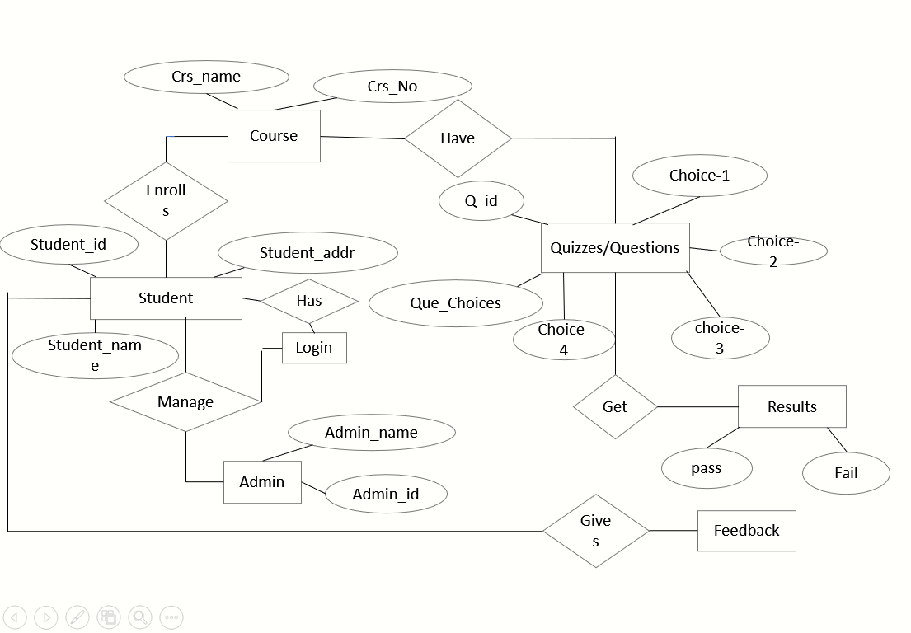

4.2 Context Level Diagram
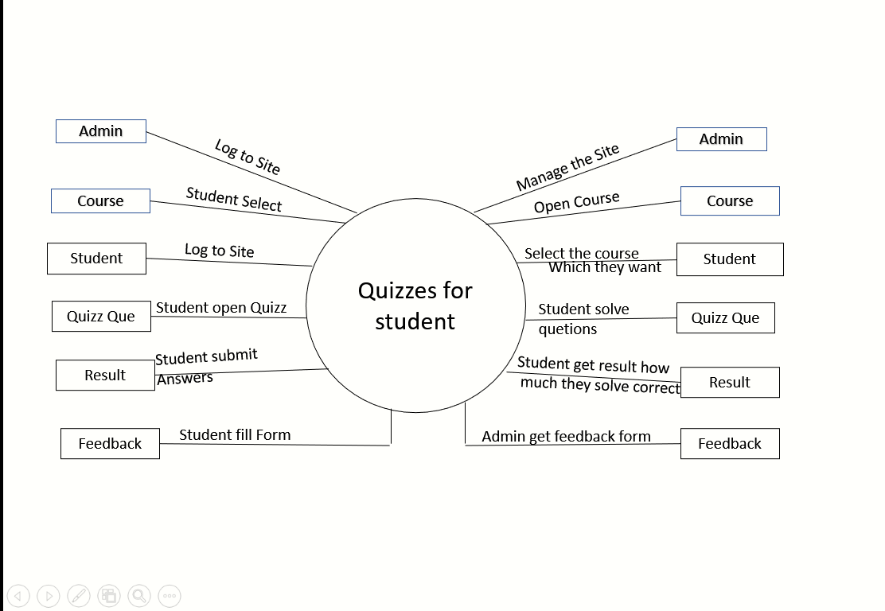

4.3 Data Flow Diagram
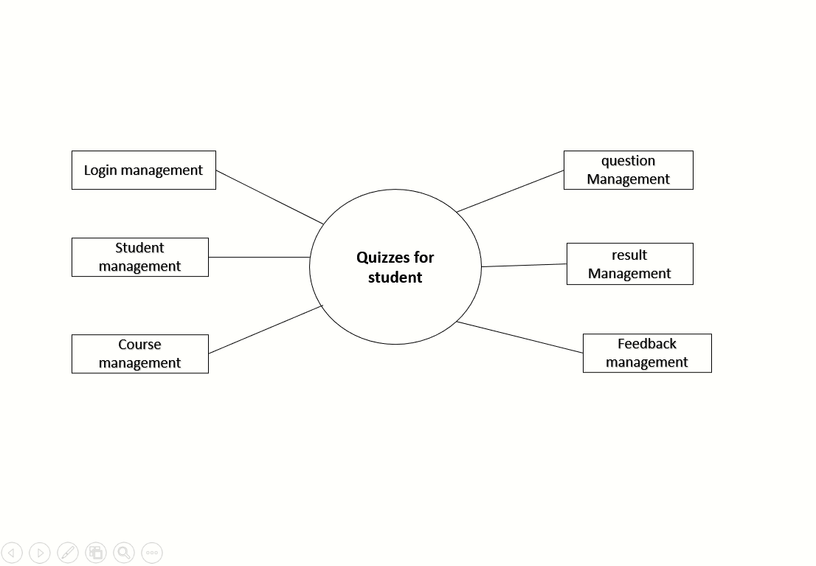
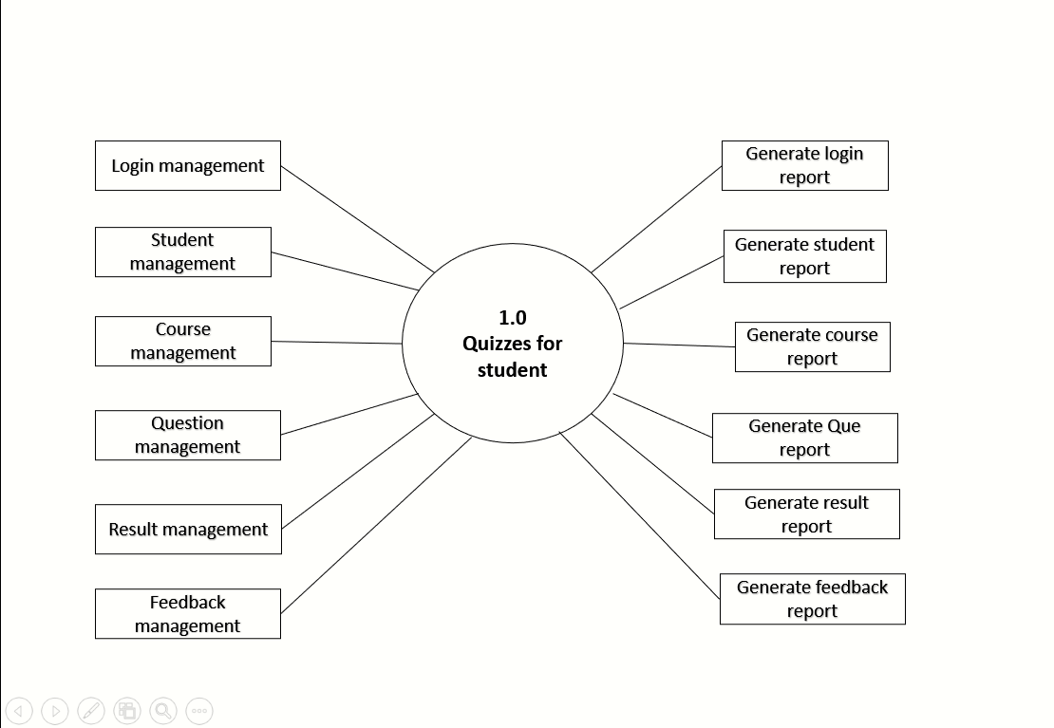
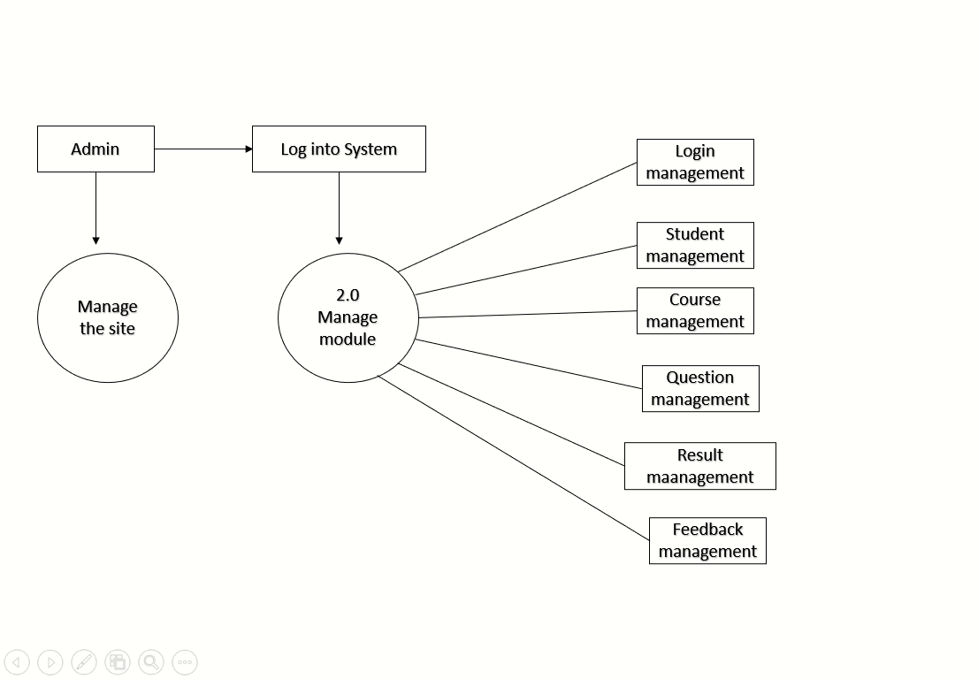

4.4 Class Diagram
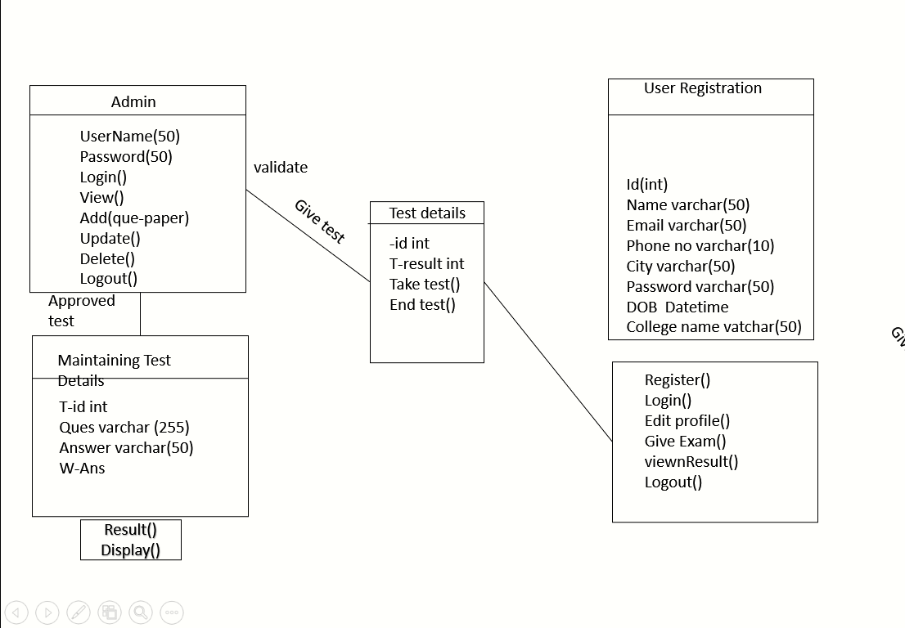

4.5 Use Case Diagram
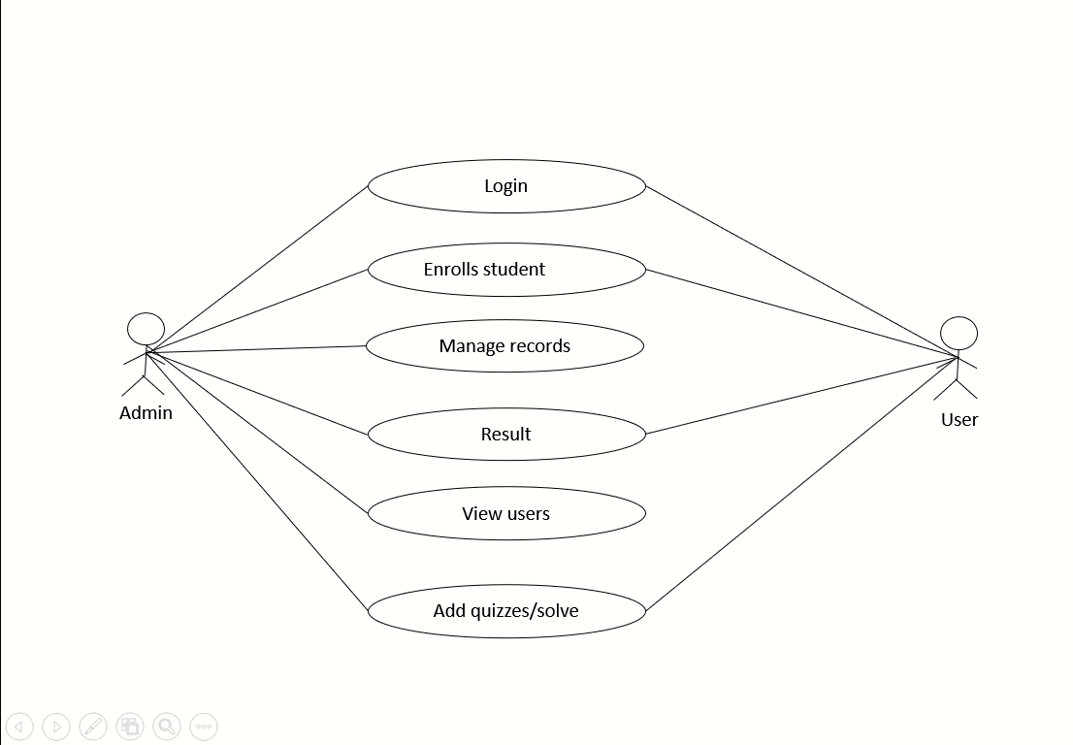

4.6 Sequence Diagram
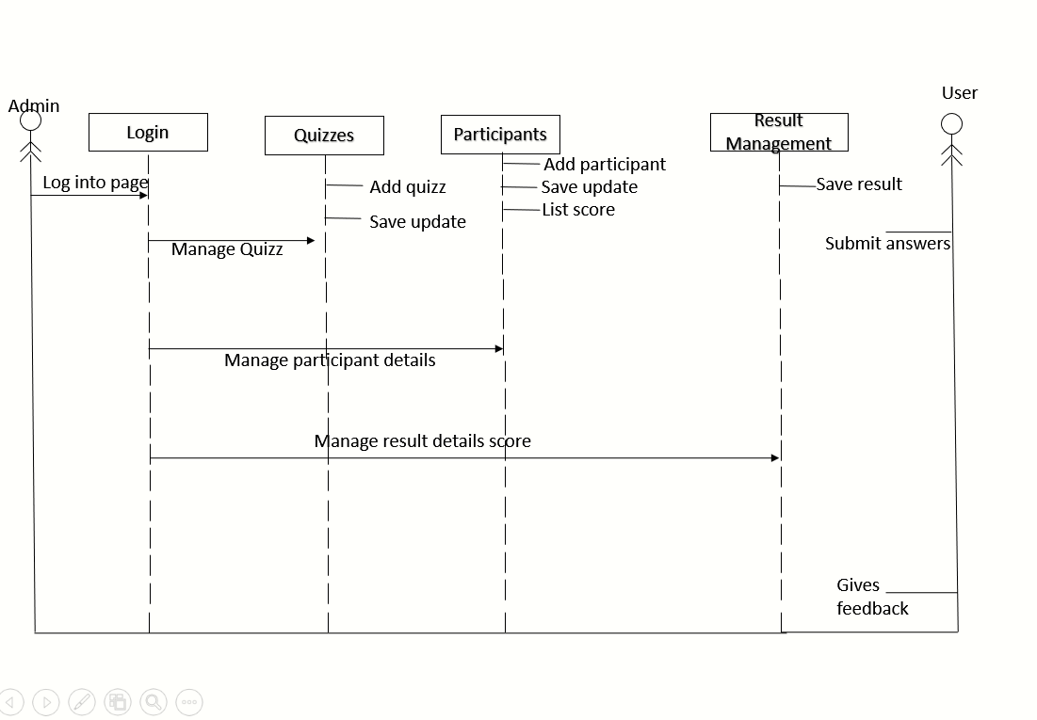

4.7 Deployment Diagram
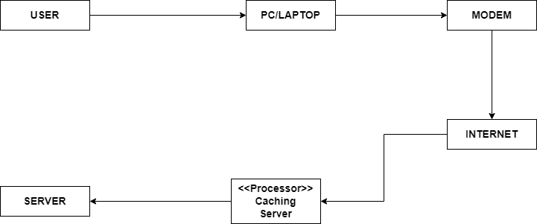

5. Data Dictionary

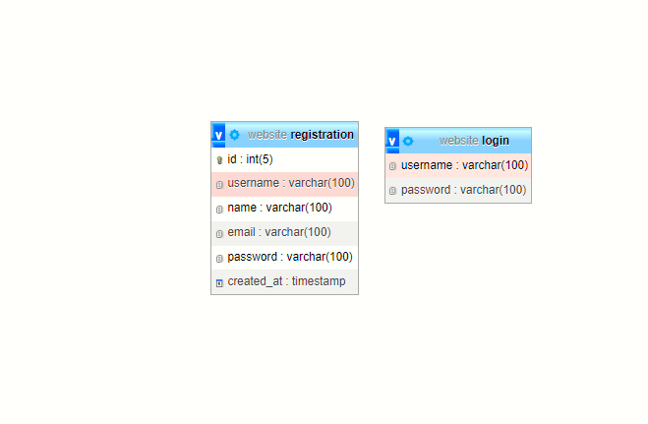

6. Design of Inputs
- Homepage

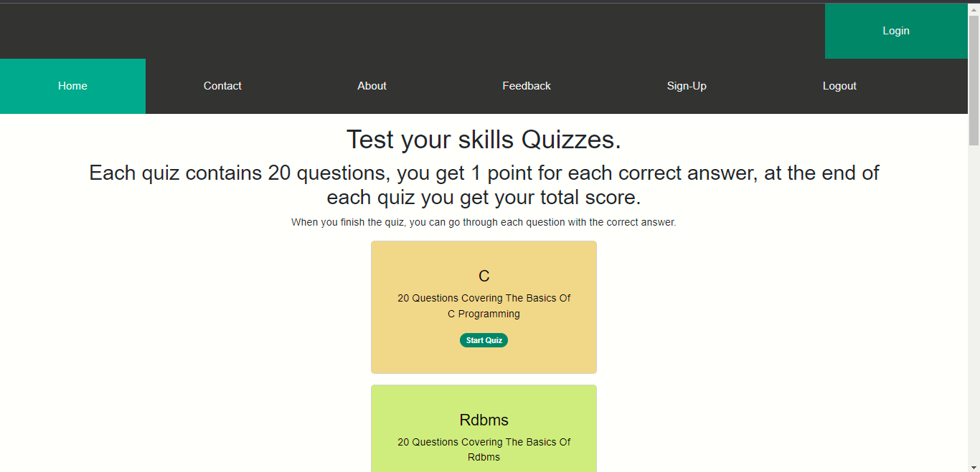

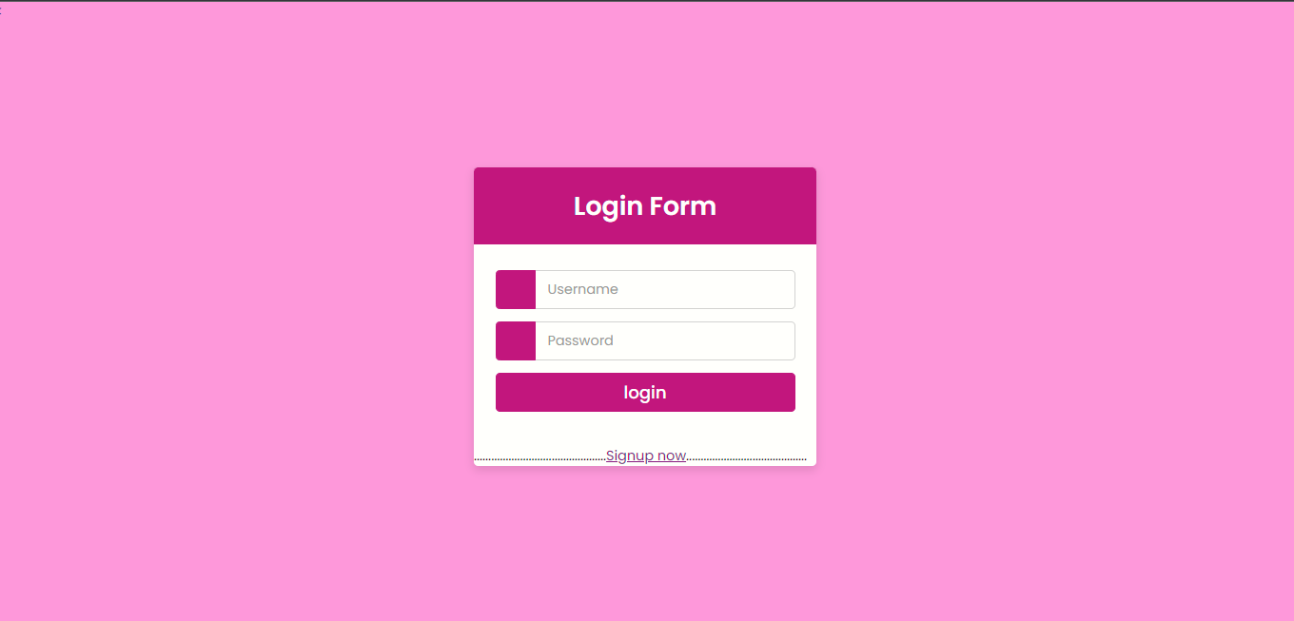
- Login page

- Signup Page

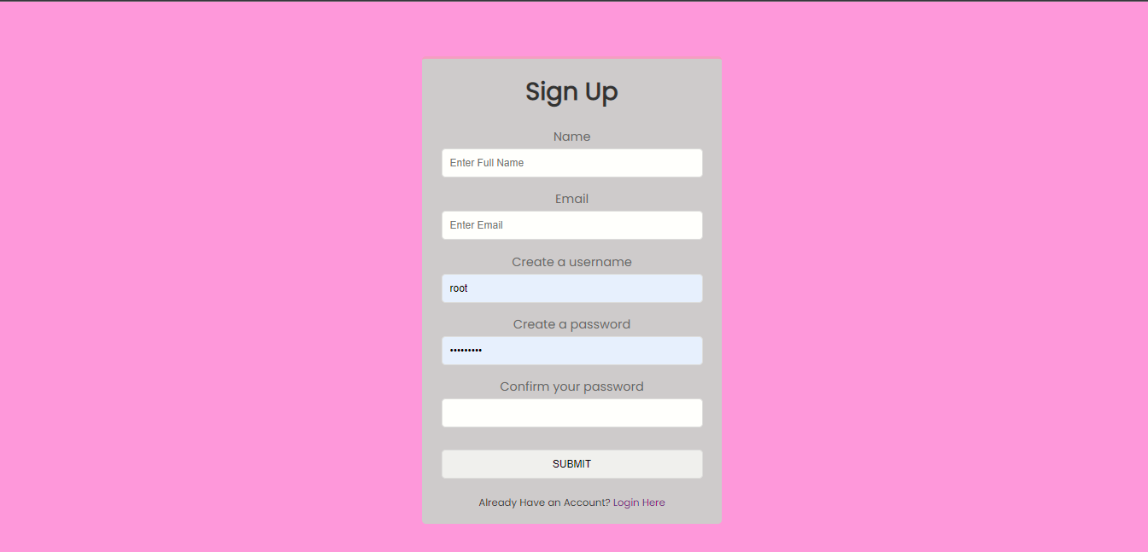
- User DB

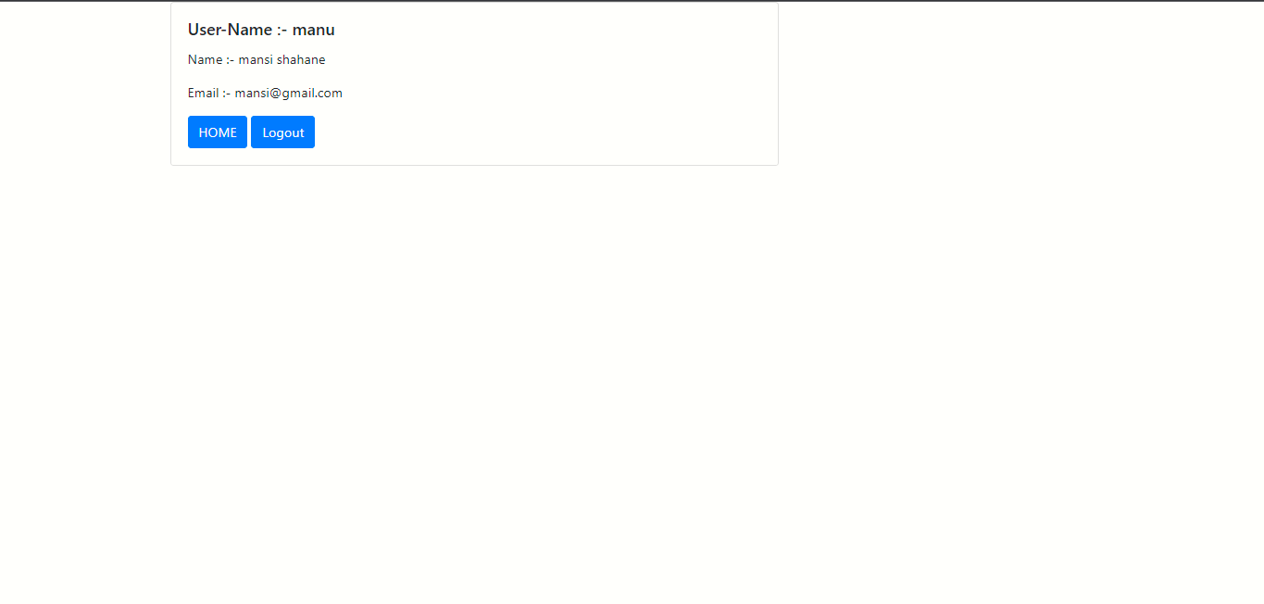
- Feedback Page

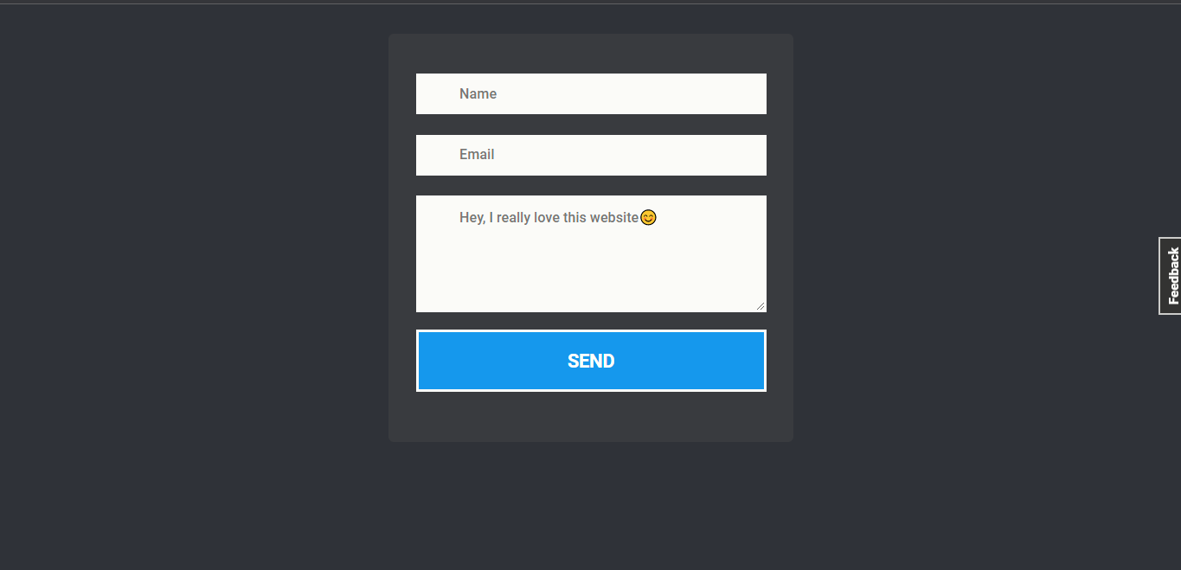

7. Conclusion

- Online Quiz is a web application. The key concept is to minimize the amount of paper and convert all forms of documentation to digital form.
- It can observe that the information required can be obtained with ease and accuracy in the computerized system.
- The user with Minimum knowledge about computer can be able operate the system easily. The system also produces brief result required by the management.

7.1 Future Enhancement
In this website, Answer will not display only result will be displayed at last. It is our future enhancement to display answer while answering the Question.

8. Bibliography

- REFERENCE BOOKS

1) PHP: A beginner’s guide

2) JavaScript: The Definitive Guide

- WEBSITE REFERENCES

1) www.google.com

2) www.w3schools.com

3) www.freshdesignweb.com

4) www.FashionResponsiveSlider

9. Annexure(Sample Code)
<!DOCTYPE html>
<html lang="en">
<head>
<title>Quizes For Student</title>
<meta charset="utf-8">
<meta name="viewport" content="width=device-width, initial-scale=1">
<link href="https://cdn.jsdelivr.net/npm/bootstrap@5.2.3/dist/css/bootstrap.min.css" rel="stylesheet">
<script src="https://cdn.jsdelivr.net/npm/bootstrap@5.2.3/dist/js/bootstrap.bundle.min.js"></script>
</head>
<style>
</style>
</head>
<body>

<div class="topnav">

<div class="login-container">
<form action="/action_page.php">
<a href="login.php"
type="button" class="bg-success">Login</a>
</form>
</div>
</div>

</body>
</html>

<style>
body {margin:0;}

.icon-bar {
width: 100%;
background-color: rgb(12, 12, 12);
overflow: auto;
}

.icon-bar a {
float: left;
width: 20%;
text-align: center;
padding: 12px 0;
transition: all 0.3s ease;
color: white;
font-size: 36px;
}

.icon-bar a:hover {
background-color: rgb(246, 238, 238);
};

.active {
background-color: rgb(250, 245, 245);
}
ul {
list-style-type: none;
margin: 0;
padding: 0;
}

/* Add a black background color to the top navigation */
.topnav {
background-color: #333;
overflow: hidden;
}

/* Style the links inside the navigation bar */
.topnav a {
float: left;
color: #f2f2f2;
text-align: center;
padding: 30px 90px;
text-decoration: none;
font-size: 17px;
}

/* Change the color of links on hover */
.topnav a:hover {
background-color: #ddd;
color: black;
}

/* Add a color to the active/current link */
.topnav a.active {
background-color: #04AA6D;
color: white;
}

</style>

<body><center>
<div class="topnav">
<a class="active" href="#home">Home</a>
<a href="#contact">Contact</a>
<a href="#about">About</a>
<a href="feedback.php">Feedback</a>
<a href="registration.php">Sign-Up</a>
<a href="logout.php">Logout</a>

</div>

<div class="container mt-3">
<h1><center>Test your skills Quizzes.</center></h1>
<h2><center>Each quiz contains 20 questions, you get 1 point for each correct answer,
at the end of each quiz you get your total score.</center></h2>
</div>
When you finish the quiz, you can go through each question with the correct answer.
<div>
<div class="container mt-3">
<div class="card" style="width:350px">
<center ><div class style="color:black;background-color:#f3d790;padding:24px">
<div class="card-body">
<h4 class="card-title">C</h4>
<p class="card-text">20 Questions Covering The Basics Of C Programming</p>
<a href="C:/xamppppp/htdocs/project2023/quizes for websites/quiz-app/C/C.html"
type="button" class="badge rounded-pill btn btn-success btn-lg">Start Quiz</a>
</center>
</div>
</div>
</div>
</div>
<div class="container mt-3"></div>
<div class="card" style="width:350px">
<center ><div class style="color:black;background-color:#e7ed7d;padding:24px">
<div class="card-body">
<h4 class="card-title">Rdbms</h4>
<p class="card-text">20 Questions Covering The Basics Of Rdbms</p>
<a href="C:/quizes for websites/quiz-app/RDMS/RDMS.html"
type="button" class="badge rounded-pill btn btn-success btn-lg">Start Quiz</a>
</center>
</div>
</div>
</div>
</div>
<div class="container mt-3"></div>
<div class="card" style="width:350px">
<center ><div class="bg-secondary">
<div class style="color:black;background-color:#f5caf4;padding:24px">
<h4 class="card-title">Business communication</h4>
<p class="card-text">20 Questions Covering The Basics Of Business communication</p>
<a href="G:/quizes for websites/quiz-app/BC/BC.html"
type="button" class="badge rounded-pill btn btn-success btn-lg">Start Quiz</a>
</center>
</div>
</div>
</div>

<div class="container mt-3"></div>
<div class="card" style="width:350px">
<center ><div class style="color:black;background-color:#dfc7f1;padding:24px">
<div class="card-body">
<h4 class="card-title">C++</h4>
<p class="card-text">20 Questions Covering The Basics Of C++</p>
<a href="G:/quizes for websites/quiz-app/c++/C++.html"
type="button" class="badge rounded-pill btn btn-success btn-lg">Start Quiz</a>
</center>
</div>
</div>
</div>
<div class="container mt-3"></div>
<div class="card" style="width:350px">
<center ><div class style="color:black;background-color:#caf5dc;padding:24px">
<div class="card-body">
<h4 class="card-title">Software Engineering</h4>
<p class="card-text">20 Questions Covering The Basics Of Software Engineering</p>
<a href="G:/quizes for websites/quiz-app/SE/SE.html"
type="button" class="badge rounded-pill btn btn-success btn-lg">Start Quiz</a>
</center>
</div>
</div>
</div>
</center>
<center>
<div class="container mt-3"></div>
<div class="card" style="width:350px">
<center><div class style="color:black;background-color:#e39dbd;padding:24px">
<div class="card-body">
<h4 class="card-title">TRW</h4>
<p class="card-text">20 Questions Covering The Basics Of TRW</p>
<a href="G:/quizes for websites/quiz-app/TRW/TRW.html"
type="button" class="badge rounded-pill btn btn-success btn-lg">Start Quiz</a>
</center>
</div>
</div>
</div>
</center>
<center>
<div class="container mt-3"></div>
<div class="card" style="width:350px">
<center ><div class style="color:black;background-color:#99c9e9;padding:24px">
<div class="card-body">
<h4 class="card-title">Digital Marketing</h4>
<p class="card-text">20 Questions Covering The Basics Of Digital Marketing</p>
<a href="G:/quizes for websites/quiz-app/Digital marketing/Digital Marketing.html"
type="button" class="badge rounded-pill btn btn-success btn-lg">Start Quiz</a>
</center>
</div>
</div>
</div>
</center>
<center>
<div class="container mt-3"></div>
<div class="card" style="width:350px">
<center ><div class style="color:black;background-color:#aaabf1;padding:24px">
<div class="card-body">
<h4 class="card-title">Web Technologies</h4>
<p class="card-text">20 Questions Covering The Basics Of Web Technologies</p>
<a href="G:/quizes for websites/quiz-app/Web technology/Web technology.html"
type="button" class="badge rounded-pill btn btn-success btn-lg">Start Quiz</a>
</center>
</div>
</div>
</div>

<div class="container mt-3"></div>
<div class="card" style="width:350px">
<center ><div class style="color:black;background-color:#bdd0f1;padding:24px">
<div class="card-body">
<h4 class="card-title">LCS</h4>
<p class="card-text">20 Questions Covering The Basics Of LCS </p>
<a href="G:/quizes for websites/quiz-app/lcs/LCS.html"
type="button" class="badge rounded-pill btn btn-success btn-lg">Start Quiz</a>
</center>
</div>
</div>
</div>

<div class="container mt-3"></div>
<div class="card" style="width:350px">
<center ><div class="bg-secondary">
<div class style="color:black;background-color:#b7deed;padding:24px">
<h4 class="card-title">PPM & OB</h4>
<p class="card-text">20 Questions Covering The Basics Of PPM & OB</p>
<a href="G:/quizes for websites/quiz-app/PPM&OB/PPM&OB.html"
type="button" class="badge rounded-pill btn btn-success btn-lg">Start Quiz</a>
</center>
</div>
</div>
</div>

</center>
</body>
</html>

